**# KeyFOB**

**(A fun project with LED and Buzzer)**

**Description:**

**Independently designed and developed a Programmable Key FOB with integrated Attiny85 microcontroller, featuring LED and buzzer functionality, using KiCad software. This project highlights proficiency in PCB layout, circuit design, and electronic prototyping.**

**It contains:**

1. 1 RGB LEDs.

<https://evelta.com/0603-rgb-smd-tri-color-led/#productDescription>

1. USB connector direct pluggable. (for Programming)

Tutorial link: <https://www.youtube.com/watch?v=VlCYI2U-qyM>

1. Buzzer (to generate music): <https://www.circuitbasics.com/how-to-use-active-and-passive-buzzers-on-the-arduino/>
2. Microcontroller (STM32WB55CEU6).
3. single click button to turn it on and off.
4. Multi-Layer Board stack up:

1] <https://jlcpcb.com/impedance>

2] <https://jlcpcb.com/help/article/multi-layer-pcb-standard-laminated-structures>

3] https://controllerstech.com/pwm-in-stm32/

**Uses:**

Just for fun to blink leds on board.

Play with RGB lights.

Music generator with onboard buzzer.

This usb slot can be inserted in laptop usb to program microcontroller. Or send some settings to configure led sequence.

**Technology used:**

1. As mentioned, key fobs communicate with your car using RFID or other advanced wireless technologies like Bluetooth, [BLE](https://www.autopi.io/glossary/bluetooth-low-energy/) or Near Field Communication (NFC).
2. Add boot loader to the circuit.
3. Identify the type of buzzer. (with 3v and automatic)
4. Add proper RGB LED,

BLE technology:

Bluetooth, a simple wireless communication module most popular since the last few decades and easy to use are being used in most of the battery-powered devices. Over the years, there have been many upgrades of Bluetooth standard to keep fulfil the demand of customers and technology according to the need of time and situation. It all started from Bluetooth version 1.0 and currently, Bluetooth version 5.0 is available in the market. Over the few years, there are many things changed including data transmission rate, power consumption with wearable and IoT Devices and Security System. To learn about the Bluetooth working, HC-05 & HC-06 is widely available in the market. But here we are going to learn about HM-10 BLE 4.0 with Arduino Board. The HM-10 is a readily available Bluetooth 4.0 module. This module is used for establishing wireless data communication using any Android App in the smartphone. The module is designed by using the Texas Instruments CC2540 or CC2541 Bluetooth low energy (BLE) System on Chip (SoC). The module design and firmware originated from the Jinan Huamao Technology Company. As the name suggests, BLE focuses on low energy consumption. Low energy focus comes with some sacrifices particularly around data transfer rates and the range of operation. With all the hype around IoT (Internet of Things) and the slew of technologies and devices out in the market, BLE is attempting to position itself as a leader for the future of IoT.

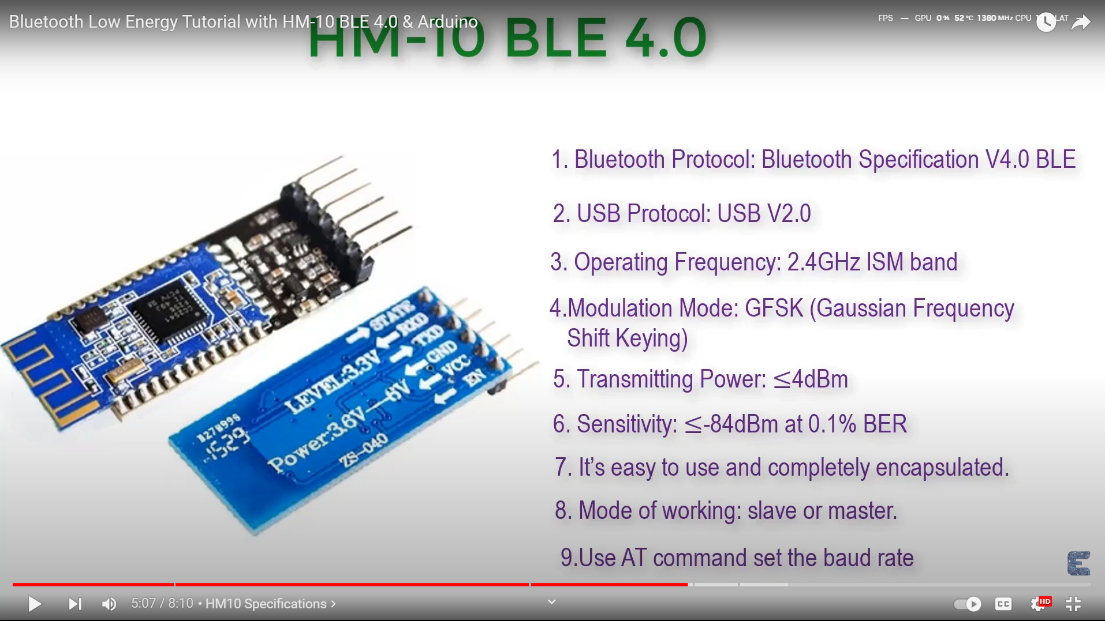

* ***We can use it through the mobile phone.***

Questions:

1. Check Ask about schematic board constrains
2. Check schematic
3. Check PCB layout
4. Ask about capacitor placement in pcb layout.
5. What type of Bluetooth antenna I should connect?
6. How should I boot load the STM32 board.
7. Check the footprint assignments?
8. Is there any need to add the bootloader?
9. Ask about the type of buzzer used here?
10. Ask about the PCB layout constrains for making the RF PCB with four layers?
11. Choosing the right dielectric values at the PCB constrains section and the material no specified there?
12. Select antenna chip and chip placement method.
13. Not getting the antenna on the websites.
14. Ask about the battery location placement and buzzer placement.

Reference Screenshots: 